INTELLIGENT FRONT-DESK FRAMEWORK FOR ENHANCING PATIENT FLOW IN HOSPITALS

Akshaya Sri P S
Department of Electronics and Communication Engineering
Ahalia School of Engineering and Technology
Palakkad, Kerala, India
akshayasri.ps@ahalia.ac.in
Mehrin Ayisha S
Department of Electronics and Communication Engineering
Ahalia School of Engineering and Technology
Palakkad, Kerala, India mehrin.ayisha@ahalia.ac.in
Anamika S
Department of Electronics and Communication Engineering
Ahalia School of Engineering and Technology
Palakkad, Kerala, India
anamika.s@ahalia.ac.in
Dr. V . Balamurugan
Department of Electronics and Communication Engineering
Ahalia School of Engineering and Technology
Palakkad, Kerala, India hodece.aset@ahalia.ac.in
Manu S Vignesh
Department of Electronics and Communication Engineering
Ahalia School of Engineering and Technology
Palakkad, Kerala, India
manu.s.vignesh@ahalia.ac.in

Abstract— Hospitals often face delays not simply due to a shortage of doctors, but because front desk processes can become disorganized and slow. The Intelligent Front Desk Framework focuses on this initial stage, allowing patients to register themselves and be directed to the appropriate department with minimal confusion. Built on a Raspberry Pi 4B with a touchscreen and developed using Python, the system remains relatively affordable and practical. Patients enter their symptoms and basic details, after which the system determines the suitable department and generates a consultation token. All information is stored in Firebase, making it easily accessible for staff, who can also manage patient and doctor data through a separate interface. While it does not address every operational challenge, it helps reduce waiting time and eases some of the repetitive workload at the reception.
Key Words: Patient registration, hospital automation, patient flow, department allocation, Raspberry Pi, Python, Firebase, token generation.
- INTRODUCTION
The Intelligent Front Desk Framework attempts to lessen that pressure, but I don't think any solution can totally remove it. Instead of relying entirely on human judgment, the process is partially automated. The setup uses a Raspberry Pi 4B with a touchscreen and Python, which, despite its extremely basic hardware, is surprisingly capable for this kind of work. Patients enter their data and descriptions of their symptoms directly into the system. After that, the framework attempts to guide them to the appropriate department and assigns them a token number for their turn. Since Firebase is used to store all patient data in a cloud database, hospital staff can access and manage patient data using a specific interface.

- LITERATURE REVIEW
Reinhold Haux talks about hospitals moving from paper records to systems. He does not make it sound like a deal. It feels like something that has been happening for years without anyone noticing. If you think about your visit to a clinic, you can see the change. There used to be stacks of files on desks but now there are computers. The reason for this change is simple. Digital records can be shared easily. Different departments can work together better. Patients can move through the system quickly.
The change is not happening at the same pace everywhere. Some hospitals seem to be doing with digital systems while others are still using paper and computers together. It looks a little awkward. Indranil Bardhan and Mark F. Thouin look at this change from a perspective. They focus on how digital systems affect the work that people do in hospitals. Their point is that technology changes hospital work in ways that you might not notice away. Some tasks that used to be repetitive or time-consuming can be done quickly. In some cases, you can see a difference in a few days. It does not always work out that way. A digital system that is not designed well can actually make things slower. If you have seen a nurse struggling with a computer or a confusing form you might not think that digital systems are always an improvement. Digital systems, like the ones Reinhold Haux and others talk about can be helpful. They are not perfect. Digital systems and the way they are used in hospitals are still changing.
The first point of contact between patients and the system is outpatient registration, which Zhang and his team focus on. They enable people to sign up on their own and get a token without much help. Imagining what this looks like is simple. A patient walks in, touches something on a screen, and gets a number in a matter of minutes. This is really simple. It makes you think about something important. Some people, like elderly patients who would rather talk to someone than use a menu, are not proficient with touchscreens.

Rainu Kaushal and her colleagues concentrate on electronic patient records, emphasizing their role in improving information access and reducing human error. As a matter of fact, this may lead to fewer times when a doctor flips through pages in an attempt to find a missing detail. Instead, the information is available, searchable, and organized. However, digitization is not without its difficulties. Data security issues typically arise quickly, making dependability crucial. Even a brief system failure can cause an entire workflow to be disrupted.

A. M. Kuo highlights how cloud platforms offer scalable storage and quick access to medical data, which makes managing records across departments far less cumbersome. Nabil Sultan adds that these systems can reduce the need for expensive physical infrastructure while making it easier for hospital teams to collaborate and monitor operations from a central point. The benefits are clear, although reliance on cloud services does raise ongoing concerns about privacy and long-term data control.
Alongside these developments, smaller and more affordable technologies are also finding a place in healthcare settings. Devices like the Raspberry Pi, while not originally designed for medical environments, have proven useful because they are inexpensive, flexible, and easy to integrate with sensors, touchscreens, and cloud services. Their presence suggests that innovation in healthcare does not always come from large, complex systems. Sometimes, it emerges from simple tools used thoughtfully.

- REQUIREMENTS AND PROPOSED ALGORITHM
- HARDWARE REQUIREMENTS
- Raspberry Pi 4 Model B+: Acts as the main processing unit, Runs the server and handles all operations.
- Wave share 7-inch Touchscreen Display: Used for user interaction, Displays the web interface for patient.
- 32 GB Micro SD Card: Stores operating system and application files
- Power Supply (5V, 3A Adapter): Provides power to Raspberry Pi.
- USB Microphone: Used for voice input (speech recognition)
- Speaker / Audio Output Device: Used for text-to-speech announcements
- Internet Connection (Wi-Fi / Ethernet): Required for Firebase and SMS API communication
- Connecting Cables: HDMI cable, Power cable
- Cabinet / Enclosure: For safe and proper installation of the system
- SOFTWARE REQUIREMENTS
- Operating System Raspberry Pi OS (Bullseye / Bookworm)
- Programming Language: Python 3.9 or above
- Web Framework: Flask (for server and web interface)
- Database: Firebase Realtime Database
- Libraries / Modules - firebase admin (for Firebase integration) - speech recognition (for voice input) - pyttsx3 (for text-to-speech) - Pillow (PIL) (for image generation), threading, datetime, os(built-in modules)
- Browser: Chromium Browser (for kiosk mode display)
- SMS API Service : Twilio / Fast2SMS / other SMS gateway
- Audio Drivers: ALSA (for microphone and speaker support)
- Internet Requirement: Required for speech recognition and SMS services.
- BLOCK DIAGRAM
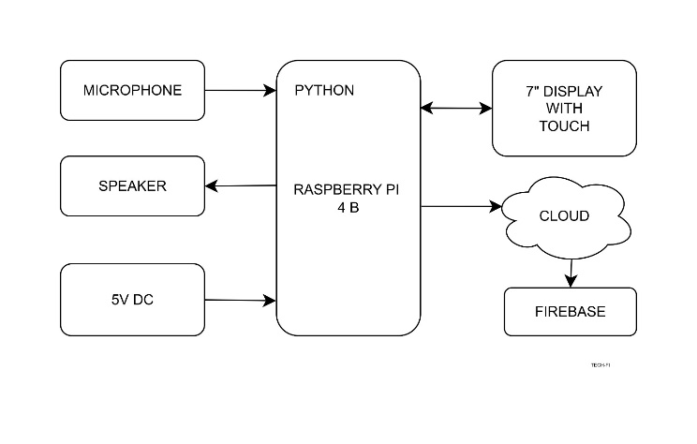
Fig. 1. Block Diagram
- Raspberry Pi 4 Model B: The Raspberry Pi 4 Model B acts as the core of the system, handling almost everything that happens. It receives input from the touchscreen or microphone and processes it using a Python program. Based on the patient’s symptoms, it selects the appropriate department, shows available doctors, generates a token number, and even manages payment tasks. At the same time, it keeps the system connected to the cloud database, making sure all data stays updated. In simple terms, it works as the central unit where input, processing, and communication come together.
- Python: Python, on the other hand, provides the system with its logic and structure. If the Raspberry Pi can be thought of as the body, then Python feels more like the part that guides its actions. It handles everything from patient registration to symptom analysis and communication with the database. At the same time, the way it is written matters quite a bit. A program that is too rigid or overly simplified might misread symptoms or struggle to adapt to the variety of situations that come up in a real hospital setting.
- Microphone: The addition of a microphone brings in a layer of accessibility that feels genuinely useful. Instead of typing everything out, patients can simply speak about what they are experiencing. For someone elderly, or even someone a bit uneasy around touchscreens, that small shift can make the interaction less stressful and more natural. At the same time, voice input is not always as smooth as it sounds in theory. Accents, background noise, or even a moment of hesitation while choosing words can change how the system interprets what is said. So while it opens the door for easier access, it also introduces a level of uncertainty that the system has to carefully manage
- Speaker: Alongside this, the speaker works almost like a quiet guide in the background. It gives spoken feedback, confirming registration, offering simple instructions, or pointing patients toward the right department. For someone who finds screens difficult to read, or who is already a bit overwhelmed by the hospital environment, hearing clear directions can make the whole process feel more manageable. That said, its usefulness probably depends on the setting. In a calm space, the guidance would be easy to follow. In a crowded waiting area, though, with conversations, footsteps, and general noise, those audio cues might not always land as intended. So while the idea is thoughtful, its effectiveness may vary depending on how controlled the environment is.
- 5V DC Power Supply: The 5V DC power supply might seem like a small detail, but it quietly holds the whole system together. It keeps the Raspberry Pi and its connected components running steadily, without interruption. Without that stability, even a well-designed setup can start to feel fragile. A slight fluctuation or an unexpected shutdown is not just a technical glitch here. It could interrupt patient registration, lose data mid-process, or delay decisions at the wrong moment. In a hospital setting, those interruptions are more than inconvenient. They can quickly become serious, which makes reliable power less of a background feature and more of a necessity.
- Cloud: The cloud extends the system beyond its local setup, linking it to a wider network where data can move more freely. Patient information, once entered, does not just sit in one place. It can be stored, accessed, and updated in real time, which means different departments are not working in isolation anymore. A doctor in one section can see what has already been recorded elsewhere, and that continuity, even in small moments, can make the process feel more coordinated. Still, this convenience comes with a quiet trade-off. The whole arrangement leans heavily on stable internet connectivity. In environments where the network drops or slows down, the system might struggle to keep up, and that gap can interrupt what is otherwise a smooth flow of information.
- Firebase: Firebase serves as the backbone for data storage and management. It holds patient details, symptoms, department assignments, doctor selections, payment status, and token numbers. Beyond storage, it also supports the hospital’s web interface, enabling staff to access and manage records efficiently. The real-time update feature is particularly valuable, though, like any cloud-based solution, it brings up ongoing questions about data security and long-term maintenance.
- FLOWCHART
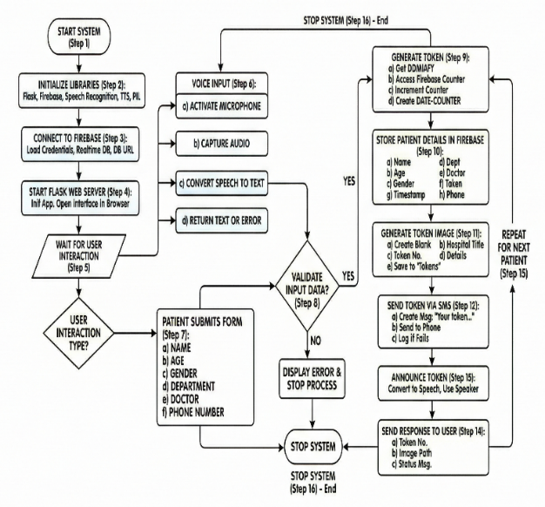
Fig. 2. Flowchart
5. ALGORITHM
- Step 1: Start the system.
- Step 2: Initialize all required libraries such as Flask, Firebase, Speech Recognition, Text-to-Speech, and PIL.
- Step 3: Load Firebase credentials and connect to the Realtime Database using the database URL.
- Step 4: Initialize Flask application and start the web server. Open the interface in the browser.
- Step 5: Wait for user interaction.
Step 6: If voice input is used: Activate the microphone, capture audio, convert speech to text, return recognized text or an error.
- Step 7: When patient submits form: Read Name, Read Age, Read Gender, Read Department, Read Doctor, Read Phone Number.
- Step 8: Validate input data. If any required field is missing, display an error and stop the process.
- Step 9: Generate token number:
- Step 10: Get current date in DDMMYY format, Access token counter from Firebase for selected department, Increment counter safely, Create token as: DATE-COUNTER.
- Step 10: Store patient details in Firebase: Name, Age, Gender, Department, Doctor, Token, Time stamp, Phone Number.
- Step 11: Generate token image: Create a blank image, print the hospital title, print the token number, print patient details, save image in tokens folder.
- Step 12: Send token via SMS: Create message: "Your token number is XX-XX for [Department]", Use SMS API to send message to patient phone number, If SMS fails, log error and continue.
- Step 13: Convert the token message to speech and announce using the speaker.
- Step 14: Send response to user: Token number, Image path, Status message.
- Step 15: Repeat the process for the next patient.
- Step 16: Stop the system only when manually terminated.
- END.
- OBSERVATIONS
The system, for the most part, manages to capture and interpret patient voice input with a fairly reliable level of accuracy, at least under normal conditions where background noise is minimal and speech is clear. Data handling is another area where the system feels quietly efficient. By relying on Firebase for cloud integration, information is synchronized almost immediately, allowing hospital staff to access updates without delay. The dashboard, too, is laid out in a way that does not require much training to understand. At the same time, a few limitations are hard to ignore. The system sends billing details via SMS, which is convenient, especially for patients who prefer digital records over paper slips. The touchscreen interface also feels intuitive enough for first-time users. However, all of this rests heavily on stable internet connectivity.

- RESULTS
The image presents the hardware prototype of what is described as an AI-powered smart triage system. At its center is a touchscreen display, fitted neatly a protective enclosure, which seems designed with the realities of a hospital environment in mind. The screen functions as the main point of interaction. Patients can enter their details directly, tapping through options much like they would on a self-service kiosk, or, if that feels cumbersome, they can speak into a microphone and rely on voice input instead. Behind the scenes, the system runs on a Raspberry Pi, which handles the incoming data along with the AI-driven processing. The results are then pushed back to the display in a form that is meant to be immediately useful, things like token numbers, doctor assignments, and even basic directions within the facility. The system operates as a compact loop where input, processing, and output all take place within a single unit. The inclusion of a speaker improves accessibility by providing audio feedback, which can be helpful for users who find screens difficult to read or navigate. However, its effectiveness may be limited in noisy environments where announcements can be easily missed. Overall, the use of touch, voice, and audio response shows an effort to support different types of users rather than relying on just one mode of interaction.
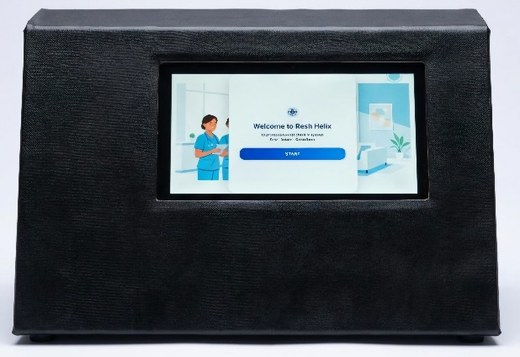

Fig 3: Patient Interaction and Work Flow Dashboard
The system organizes patient records by date and then by departments such as Cardiology, Dermatology, General Medicine, and Orthopedics. This structure is practical and makes it easy to track patient flow, though it may become harder to manage on very busy days. The token counter, while simple, plays an important role by assigning unique numbers and preventing confusion in queues. It helps avoid issues like duplicate tokens or unclear order. Overall, the system relies on real-time synchronization to keep information updated across departments, allowing smoother coordination without constant manual effort.
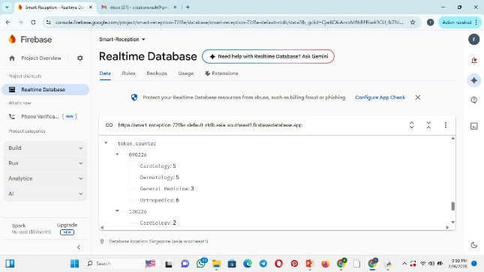

Fig 4: Cloud Database

The dashboard, titled “Full Database History,” presents patient records in a clear table format, showing details like date, token number, name, age, gender, department, doctor, and status. It is easy to scan, which is useful in a busy hospital where quick access to information is important. On the left, a control panel offers options such as Live Queue, View History, and Save to TXT. These features are simple but practical, allowing staff to switch between current and past records and export data when needed. Overall, the dashboard keeps everything in one place, reducing the need to move between different systems. This helps improve efficiency, though it may become harder to manage as the amount of data increases over time.
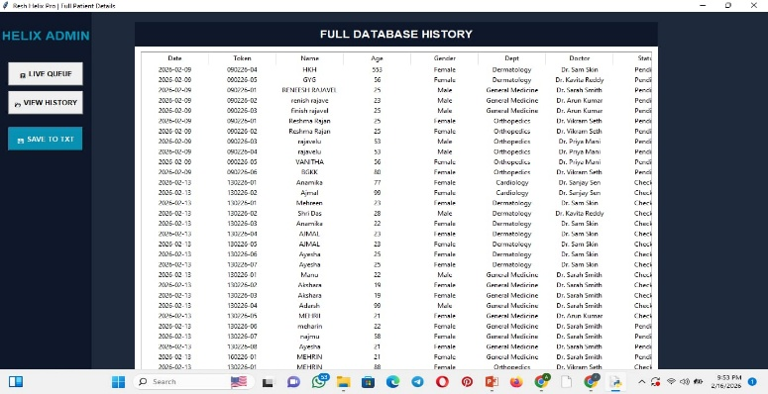

Fig 5: Admin Dashboard

- CONCLUSION
When seen in actual use rather than just in theory, the Intelligent Front Desk Framework feels less like a single tool and more like a coordinated system aimed at easing common hospital bottlenecks. By combining voice input, AI-based processing, and cloud support, it takes over routine tasks that are often repetitive and time-consuming. One clear outcome is the real-time dashboard, where token numbers and doctor assignments appear instantly. At the same time, patient data is updated in Firebase, keeping records consistent and accessible across the system. A separate management webpage allows staff to monitor activities without relying entirely on manual checks. Features like navigation guidance and SMS billing further add to its practicality. Overall, the system supports a more efficient workflow while still leaving room for human involvement. It does not replace staff but helps reduce their workload and, in many cases, makes the experience smoother for patients.

- REFERENCES
- A. Tahernejad et al., “Application of artificial intelligence in triage in emergencies and disasters: systematic review,” BMC Public Health, vol. 24, 2024.
- X. Liu et al., “Assessing the utility of artificial intelligence in outpatient triage: A randomized clinical study,” Frontiers in Public Health, vol. 12, 2024.
- S. Tyler et al., “Use of artificial intelligence in triage in hospital emergency departments: A scoping review,” Cureus, vol. 16, no. 5, 2024.
- Z. Mani and B. Albagawi, “AI frontiers in emergency care: The next evolution of nursing interventions,” Frontiers in Public Health, vol. 12, 2024.
- H. Alimiri Dehbaghi and K. Khoshgard, “The role of artificial intelligence in diagnosis, triage, and patient management,” International Journal of Emergency Medicine, vol. 18, 2025.
- “The role of artificial intelligence in enhancing triage decisions in healthcare settings,” Applied Nursing Research, 2025.
- R. Awasthi et al., “Artificial Intelligence in Healthcare: 2023 Year in Review,” medRxiv, 2024
- Q. Shi et al., “C-PATH: Conversational patient assistance and triage in healthcare system,” arXiv preprint, 2025.

.

